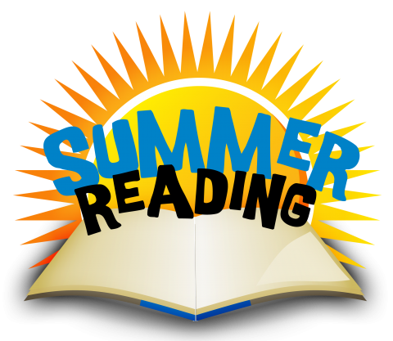
Over the summer, please read the following books before entering 2nd grade:
- Horrible Harry and the Stolen Cookie by Suzie Kline
- Henry & Mudge and the Big Sleepover by Cynthia Rylant
**For each book, students must choose one of the two worksheets provided. 1 for Horrible Harry and the Stolen Cookie and 1for Henry & Mudge and the Big Sleepover All reading and worksheets (2) are due on the first day of school. **

The following books are recommended non-fiction titles for 2nd grade:
- Magic Tree House Fact Tracker: Dog Heroes by Mary Pope Osborne and Nathalie Pope Boyce
- Dinosaur Days by Joyce Milton

